Dynamics of a Tug Boat

The best way to plan the path of a vehicle is to know a bit about its dynamics. In the case of a tugboat this means predicting the path of the boat given if you know what the rudder and propeller are doing. Unfortunately the interaction between the water and the tugboat is fairly complicated, so instead of deriving a model for the boat we have collected a bit of data on the boat.

This document explains how to interpret the boat data, to give you a better perspective on controlling the boat and so that you might be able to collect and interpret your own data.

# File Format

The current boat data is formatted in a series of CSV files. The file names are “rudder_test***x***.csv” where *x* is a number that corresponds to the rudder position during that test. The mapping between the rudder number, *x*, and the rudder angle can be found in the file “angles.csv”.

## rudder_test***x***.csv

This data was collected by fixing the rudder position and allowing the boat to accelerate up to speed. Data from the boat’s position was then taken from the base station and logged in this CSV file directly from LabVIEW.

Open one of these files in Excel, or an equivalent program. As you might be able to see, the first two rows in the CSV file contains header information including:

* Test Type
* Operator Name
* Boat Name
* Rudder Position (0-14)
* Speed (0-14)

The third row contains the header for the data and every row after that contains the data collected from the test. This data is formatted according to the heading: X, Y, Angle (Boat Heading), Time. If you have a file open in Excel you can try to plot X against Y. You should see some sort of circle (or ellipse depending on your axes).

## angles.csv

In order to map the rudder position (0-14) to actual rudder angle, we swept the rudder position and measured each of the angles with a protractor. We stored this data in the “angles.csv” file. This data is specific to the boat that it is calibrated for, every team should re-take this data.

The first row of this CSV file contains column titles “rudder position”, and “angle (degrees)”. Each row after that contains a mapping from rudder position (0-14) to rudder angle in degrees. Note that 90 degrees corresponds to the angle directly behind the boat.

# Parsing the Data

The MATLAB file “main.m” parses the data and glean information about the boat dynamics. This script is documented, but if you have any questions contact Patrick or Arjun.

This script generates a variety of plots. The first plots the raw boat positions (x,y) and fit a circle to them.

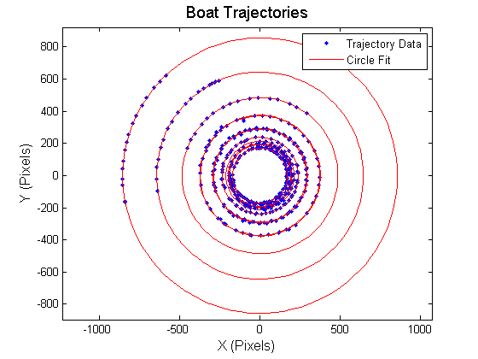

This data demonstrates that for a fixed rudder angle the boat always travels along a circle. The choice of rudder angle determines which circle the boat travels on. Exactly how the rudder angle maps to the radius is the subject of the second plot. We found experimentally that the rudder angle is directly proportional to the curvature (1/radius).

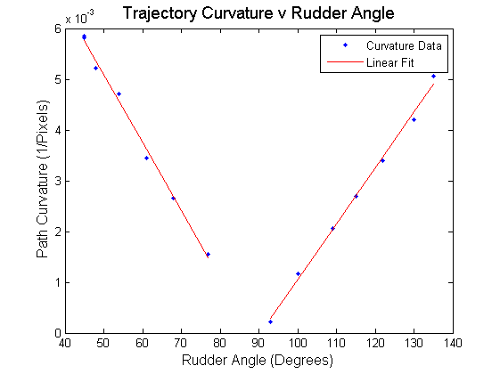

These two lines correspond to left turns and right turns. They will intersect at 90 degrees with zero curvature. This makes sense; if your rudders aren’t turned you will go straight. Visually it looks like the linear fit, but the best way to tell is by looking at the residual (error) plot.

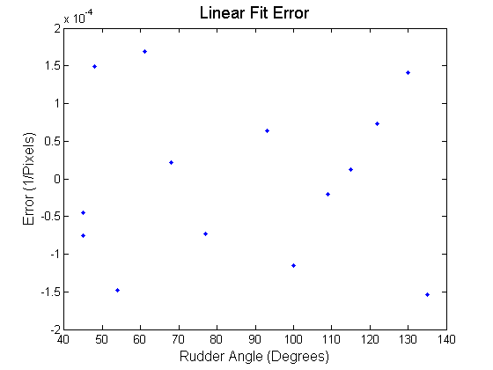

The error scale is small compared to the data and the error statistics look random suggesting that the linear fit is in fact appropriate.

# Further Work

Collect your own data to help with boat control or path planning. There are still several questions to answer:

* How does rudder command map to boat speed?
* How does boat speed affect turning?
* How does turning affect boat speed?